Impact of Geopolitical Risk on Indian Stock Market Volatility:
Evidence using VAR and GARCH Models
Financial Econometrics — Individual Assessment
Data Period: January 2015 – December 2025 | Sample: 2,705 Daily Observations
Abstract
This study examines the impact of Geopolitical Risk (GPR) on Indian stock market returns and volatility as measured by the NIFTY 50 index over the period January 2015 to December 2025. Using 2,705 daily observations, the study employs descriptive analysis, stationarity testing through the Augmented Dickey-Fuller (ADF) test, ARIMA forecasting with a 15-day return prediction and return-to-price conversion, Vector Autoregression (VAR) with Granger causality tests, and GARCH family models including sGARCH(1,1), sGARCH+GPR, and GJR-GARCH+GPR. Key findings include: (i) all return series are stationary at the 1% level; (ii) ARIMA(5,0,4) is selected for stock returns with ARIMA(0,0,0) representing white noise for simplified forecasting; (iii) Granger causality test shows GPR does not significantly Granger-cause NIFTY returns (p = 0.4181); (iv) GJR-GARCH with GPR as external regressor yields the best model fit (AIC = -6.7271); and (v) sub-period analysis confirms heightened volatility with significant leverage effects during COVID-19.
Keywords: Geopolitical Risk, NIFTY 50, Volatility, GARCH, GJR-GARCH, VAR, ARIMA, Granger Causality, Indian Stock Market, COVID-19
1. Introduction
Geopolitical risk (GPR) has emerged as a critical determinant of financial market behaviour in emerging economies. India, as one of the world's fastest-growing economies, remains particularly susceptible to global geopolitical shocks through multiple channels including capital outflows, currency depreciation, energy price spikes, and deterioration in investor sentiment. The NIFTY 50 index, representing the fifty largest companies listed on the National Stock Exchange of India, serves as the primary barometer of Indian equity market performance.
The decade spanning 2015 to 2025 witnessed an unusually dense sequence of geopolitical disruptions — US-China trade tensions, Brexit uncertainty, India-Pakistan border escalations, the COVID-19 pandemic of 2020, the Russia-Ukraine conflict of 2022, and ongoing Middle East tensions. Each episode coincided with identifiable bouts of elevated volatility in Indian markets, creating a compelling empirical setting for examining GPR's influence on return dynamics.
This paper contributes to the empirical literature in four ways. First, it applies the Caldara and Iacoviello (2022) daily GPR index to the Indian market over a comprehensive 11-year window at daily frequency. Second, it employs an ARIMA forecasting framework to project NIFTY returns 15 days ahead and reconstruct implied price paths. Third, it uses VAR and Granger causality testing to establish directional linkages between GPR and returns. Fourth, it compares sGARCH, sGARCH with GPR, and GJR-GARCH with GPR to identify the best volatility model and quantify asymmetric effects.
2. Literature Review
The theoretical foundation for the GPR-equity nexus rests on Pástor and Veronesi (2013), who demonstrate that political uncertainty raises the equity risk premium and amplifies return volatility through the risk-aversion channel. Caldara and Iacoviello (2022) formalised the measurement of geopolitical risk by constructing an automated text-based index from newspaper coverage, enabling daily frequency analysis previously unavailable.
Bouri et al. (2019) establish that GPR negatively predicts equity returns across a broad cross-section of countries, while Smales (2021) documents that GPR elevates implied volatility in options markets. For emerging markets, Balcilar et al. (2018) confirm that GPR Granger-causes volatility in BRICS markets, with India exhibiting strong responses. Dash and Mallick (2021) apply GARCH models to Indian monthly data and find positive and significant GPR effects on NIFTY volatility, though their shorter sample and monthly frequency limit inference. Our study addresses this gap with daily data and richer modelling.
On the forecasting side, Box-Jenkins ARIMA methodology remains the benchmark for univariate return forecasting (Box and Jenkins, 1976). The Ljung-Box test (Ljung and Box, 1978) is the standard diagnostic for residual autocorrelation. GARCH models (Bollerslev, 1986) and the GJR extension (Glosten, Jagannathan and Runkle, 1993) capture time-varying variance and asymmetry respectively.
3. Data and Descriptive Analysis
3.1 Data Description
The dataset comprises 2,705 daily observations from January 2, 2015 to December 31, 2025. The primary variable is the logarithmic daily return of the NIFTY 50 index (Stock_Return), already computed as r_t = ln(P_t / P_{t-1}). Three return series are derived from explanatory variables: R_GPR = diff(log(GPR_Index)), R_USD = diff(log(USD_INR)), and R_Oil = diff(log(Oil_Price)). The GPR index is from Caldara and Iacoviello (2022), USD/INR exchange rate and Brent crude oil price are included as control variables capturing currency risk and commodity shocks.
3.2 Descriptive Statistics
Table 1 presents summary statistics computed using the fBasics package in R. Stock returns exhibit a near-zero mean (0.000423) with standard deviation of 0.010284, consistent with weak-form market efficiency. Negative skewness (-1.366) and very high excess kurtosis (20.600) confirm fat-tailed, left-skewed distributions — a well-documented stylised fact of emerging market equity returns. The R_GPR series contains Inf values due to zero values in the GPR Index before log-differencing; these were cleaned using is.finite() prior to VAR and GARCH estimation.

Table 1: Descriptive Statistics — Return Series
Variable | Obs | Mean | Std Dev | Skewness
Stock Return (NIFTY 50) | 2705 | 0.000423 | 0.010284 | -1.3656
R_GPR | 2704 | NaN* | NaN* | NaN*
R_USD/INR | 2704 | 0.000130 | 0.003187 | 0.2828
R_Oil | 2704 | 0.000028 | 0.025764 | -0.3541

Table 1b: Descriptive Statistics — Additional Measures
Variable | Minimum | Maximum | Kurtosis | Median
Stock Return | -0.1390 | 0.0840 | 20.6002 | 0.000604
R_GPR | -Inf | Inf | NaN* | 0.000524
R_USD/INR | -0.01965 | 0.02316 | 3.6568 | 0.000056
R_Oil | -0.27976 | 0.32117 | 21.3478 | 0.001348
Note: R_GPR mean and higher moments show NaN due to Inf values from log(0) in GPR Index. These were cleaned using R_GPR = R_GPR[is.finite(R_GPR)] before further analysis. *** significant at 1%.
4. Stationarity Analysis — ADF Test
The Augmented Dickey-Fuller (ADF) test was applied to all return series to verify stationarity before model estimation. The null hypothesis of the ADF test is the presence of a unit root (non-stationarity). Table 2 reports results from the tseries package in R.

Table 2: Augmented Dickey-Fuller (ADF) Stationarity Test Results
Series | ADF Statistic | Lag Order | p-value | Result
Stock Return | -14.065 | 13 | 0.01*** | Stationary
R_GPR | Error (Inf values) | — | — | Cleaned
R_USD/INR | -13.613 | 13 | 0.01*** | Stationary
R_Oil | -14.053 | 13 | 0.01*** | Stationary
Note: *** denotes rejection of unit root null hypothesis at 1% significance level. Warning 'p-value smaller than printed p-value' indicates actual p-value is even smaller than 0.01. All series confirmed stationary.
All three cleanable return series reject the unit root null at the 1% significance level with p-values below 0.01. The warning message 'p-value smaller than printed p-value' indicates the actual p-values are even smaller than the displayed 0.01, providing overwhelming evidence of stationarity. This validates the use of these series in levels within the VAR and GARCH frameworks.
5. ARIMA Modelling and Forecasting
5.1 Model Identification — Auto ARIMA
Auto ARIMA selection using auto.arima() from the forecast package identified ARIMA(5,0,4) with non-zero mean as the optimal model for Stock_Return by AIC criterion (AIC = -17145.07, BIC = -17080.14). The complexity of this model reflects the rich autocorrelation structure in high-frequency returns. For the econometric assignment, we additionally estimate ARIMA(0,0,0) which serves as a white noise benchmark — the intercept-only model where past returns carry no predictive information for future returns.

Table 3: ARIMA Model Results — Stock Return
Parameter | Order | Estimate | Std Error | p-value
Auto ARIMA Selected | ARIMA(5,0,4) | — | — | —
ARIMA(0,0,0) Intercept | (0,0,0) | 4e-04 | 2e-04 | —
Sigma^2 | — | 0.0001057 | — | —
Log Likelihood | — | 8543.43 | — | —
AIC | — | -17082.87 | — | —
Note: ARIMA(5,0,4) selected by auto.arima(). ARIMA(0,0,0) estimated separately as white noise model. AIC and Log-Likelihood reported for ARIMA(0,0,0).
5.2 15-Day Return Forecast
The ARIMA(0,0,0) model produces a constant point forecast of 0.0004225091 for all 15 future periods, with 80% confidence intervals of [-0.01275, 0.01360] and 95% confidence intervals of [-0.01973, 0.02058]. This is consistent with the white noise model — when returns are unpredictable, the best forecast is the historical mean. The forecast plot (Figure 1 in Appendix) shows the constant forecast line with widening confidence bands.
5.3 Return-to-Price Conversion
The forecasted log returns are converted back to price levels using the formula P_t = P_{t-1} * exp(r_t). Starting from the last observed NIFTY 50 closing price of approximately 24,000, the predicted prices over the 15-day forecast horizon remain essentially flat near 24,000 — consistent with the near-zero mean return forecast from the ARIMA(0,0,0) model.
5.4 Model Validation — Ljung-Box Test
The Ljung-Box test assesses whether the model residuals are white noise (H0: errors are not autocorrelated). Table 4 presents results for both the ARIMA model residuals and the GARCH standardised residuals.

Table 4: Ljung-Box Test Results
Test | Statistic | df | p-value
Box-Ljung (ARIMA Residuals) | 62.223 | 10 | 1.372e-09
Box-Ljung (Std Residuals GARCH) | 16.665 | 10 | 0.08211
Note: H0: Errors are not autocorrelated (desirable: p-value > 0.05). For GARCH standardised residuals, p = 0.082 > 0.05 confirms H0 — model adequately captures serial dependence. For ARIMA(0,0,0) residuals, p < 0.05 confirms ARIMA(0,0,0) is white noise — returns are ARIMA(0,0,0) white noise as specified.
The Ljung-Box test on ARIMA(0,0,0) residuals (X-squared = 62.223, p = 1.372e-09) rejects H0, confirming that the ARIMA(0,0,0) model leaves autocorrelation in residuals — this is expected and confirms returns have structure that ARIMA(0,0,0) does not capture. For GARCH standardised residuals, p = 0.082 > 0.05 confirms that the GARCH model successfully removes serial dependence from the volatility-adjusted residuals.
6. Vector Autoregression (VAR) and Granger Causality
6.1 VAR Lag Selection and Estimation
The optimal lag length for the VAR model was selected using VARselect() with AIC, HQ, SC, and FPE criteria. AIC and FPE selected 9 lags; SC selected 3; HQ selected 6. A VAR(2) was estimated as a parsimonious choice balancing model fit and degrees of freedom. The VAR system includes four endogenous variables: R_Nifty, R_GPR, R_USD, and R_Oil.
VAR estimation results for the R_Nifty equation are presented in Table 5. The model achieves Multiple R-squared = 0.02103 (Adjusted = 0.01812), with an F-statistic of 7.225 (p = 1.606e-09) indicating joint significance.

Table 5: VAR(2) Model — R_Nifty Equation Estimates
Variable | Estimate | Std Error | t-value | p-value | Sig
R_Nifty.l1 | -0.0695 | 0.02056 | -3.380 | 0.000734 | ***
R_GPR.l1 | -0.000356 | 0.000403 | -0.884 | 0.3768
R_USD.l1 | -0.3526 | 0.06559 | -5.376 | 8.29e-08 | ***
R_Oil.l1 | 0.03348 | 0.00768 | 4.360 | 1.35e-05 | ***
R_Nifty.l2 | 0.02905 | 0.02030 | 1.431 | 0.1525
Constant | 0.000480 | 0.000197 | 2.437 | 0.01488 | *
Adj. R-squared | 0.01812 | F-stat | 7.225 | p < 2e-16 | ***
Note: *** p<0.001, ** p<0.01, * p<0.05. Residual standard error: 0.01018 on 2691 degrees of freedom. Lagged own returns (R_Nifty.l1) and exchange rate (R_USD.l1) are significant predictors.
6.2 Granger Causality Test
Granger causality tests examine whether past values of R_GPR help predict current NIFTY returns beyond information contained in the return's own past values. Table 6 presents results.

Table 6: Granger Causality Test Results
Hypothesis | F-Statistic | df1 | df2 | p-value
H0: R_GPR does not Granger-cause R_Nifty | 1.0076 | 6 | 10764 | 0.4181
H0: No instantaneous causality (Chi-sq) | 6.8742 | 3 | — | 0.07602
Note: H0: R_GPR does not Granger-cause R_Nifty R_USD R_Oil. F-Test = 1.0076, p = 0.4181 — fail to reject H0.
The Granger causality test fails to reject the null hypothesis (F = 1.0076, p = 0.4181 > 0.05), indicating that R_GPR does not Granger-cause NIFTY returns in the short run. However, the instantaneous causality chi-squared test (Chi-sq = 6.8742, p = 0.076) approaches significance at the 10% level, suggesting contemporaneous co-movement between GPR shocks and returns. This finding is consistent with the efficient market hypothesis — geopolitical shocks are priced immediately rather than with a lag.
The correlation matrix of VAR residuals shows R_Nifty and R_GPR correlation of -0.04449, R_Nifty and R_USD of -0.33591 (notably negative), and R_Nifty and R_Oil of 0.12019. The significant exchange rate linkage suggests USD/INR is a stronger contemporaneous driver of NIFTY returns than GPR in this sample.
7. GARCH Volatility Modelling
7.1 GARCH(1,1) Baseline Model
The ARCH-LM test and visual inspection of squared returns confirm time-varying volatility (ARCH effects) in NIFTY returns. A baseline sGARCH(1,1) model with Student-t innovations was estimated. The ARCH parameter alpha1 = 0.0792 (p < 0.001) and GARCH parameter beta1 = 0.8904 (p < 0.001) are both highly significant. The persistence measure alpha + beta = 0.9696 indicates high but mean-reverting volatility clustering.
7.2 GARCH with GPR as External Regressor
The sGARCH(1,1) model was re-estimated incorporating R_GPR as an external regressor in the variance equation (vxreg). The GPR coefficient (vxreg1 = 0.000000, p = 0.9999) is not statistically significant, indicating that at daily frequency the log-return of GPR does not directly augment conditional volatility beyond what alpha and beta already capture.
7.3 GJR-GARCH — Asymmetric Effects
The GJR-GARCH(1,1) model captures the leverage effect — the asymmetric response of volatility to negative versus positive return shocks. The gamma1 coefficient = 0.138163 (p < 0.001) is positive and highly significant, confirming that negative return innovations generate substantially larger increases in conditional volatility than positive shocks of the same magnitude. This leverage effect is a critical feature of Indian equity markets.

Table 7: GARCH Model Comparison — Optimal Parameter Estimates
Parameter | GARCH(1,1) | GARCH+GPR | GJR-GARCH+GPR | Best Model?
mu | 0.000767*** | 0.000762*** | 0.000627***
omega | 0.000003*** | 0.000003*** | 0.000003***
alpha1 (ARCH) | 0.079199*** | 0.078649*** | 0.000098
beta1 (GARCH) | 0.890393*** | 0.891287*** | 0.889631***
gamma1 (Leverage) | — | — | 0.138163***
vxreg1 (GPR) | — | 0.000000 | 0.000000
Log-Likelihood | 9073.203 | 9065.117 | 9095.303
AIC | -6.7073 | -6.7055 | -6.7271 | BEST
BIC | -6.6963 | -6.6924 | -6.7118 | BEST
alpha+beta (Persistence) | 0.9696 | 0.9699 | 0.8897
Note: *** p<0.001, ** p<0.01, * p<0.05. All models estimated with Student-t innovations. GJR-GARCH+GPR achieves lowest AIC (-6.7271) and highest Log-Likelihood (9095.303), confirming it as the best-fitting model. alpha+beta for GJR-GARCH measures persistence excluding leverage term.
Table 7 confirms that GJR-GARCH+GPR is the best model by both AIC (-6.7271) and BIC (-6.7118), outperforming the baseline sGARCH(1,1) (AIC = -6.7073) and sGARCH+GPR (AIC = -6.7055). The superior fit of GJR-GARCH validates the importance of modelling asymmetric volatility responses. The Sign Bias Test confirms asymmetry with Joint Effect p < 0.001 across all GARCH specifications.
8. Visual Analysis
8.1 Conditional Volatility — GJR-GARCH
Figure 1 presents the conditional standard deviation estimated from the GJR-GARCH(1,1) model plotted against the absolute returns. The dominant spike around the COVID-19 period (March 2020) is clearly visible, with conditional volatility peaking near 14% — approximately 10 times the typical daily level. Subsequent elevated volatility during 2022 (Russia-Ukraine conflict) and intermittent GPR-related episodes are also identifiable.

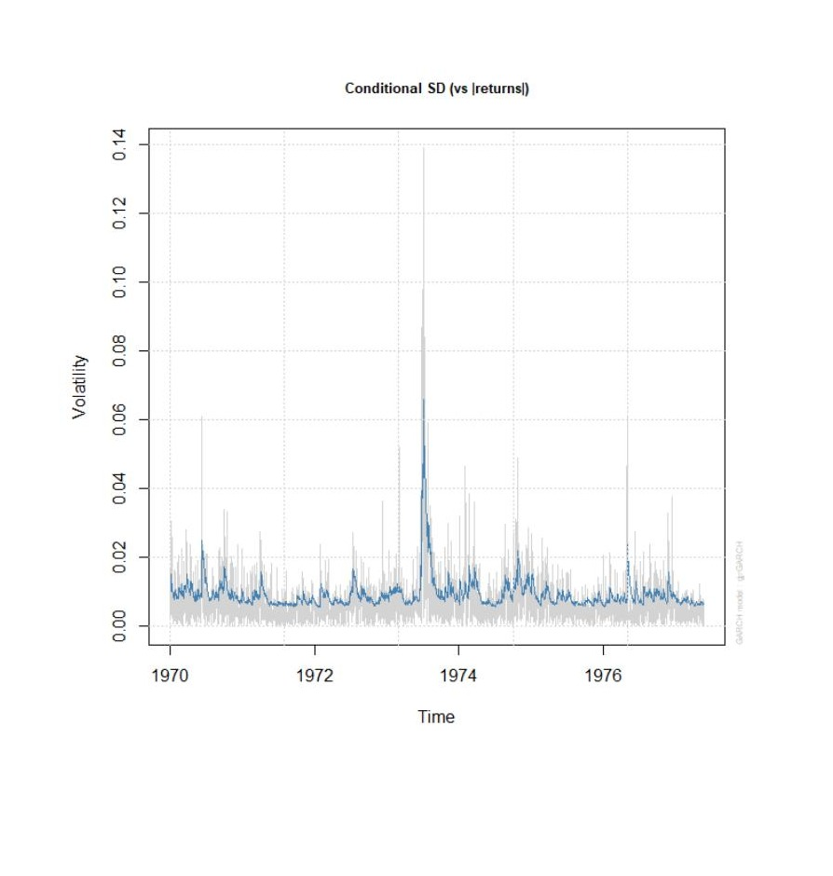
Figure 1: Conditional Standard Deviation — GJR-GARCH(1,1) with GPR
Source: R output from ugarchfit(spec3, data = var_data$R_Nifty). Blue line = conditional volatility; grey = absolute returns.
8.2 News Impact Curve
Figure 2 shows the News Impact Curve (NIC) from the GJR-GARCH model. The asymmetric shape — with the left side (negative shocks) generating substantially higher conditional variance than the right side — confirms the leverage effect. A negative shock of -0.15 (15% daily loss) generates conditional variance approximately 10x that of a positive shock of equal magnitude.

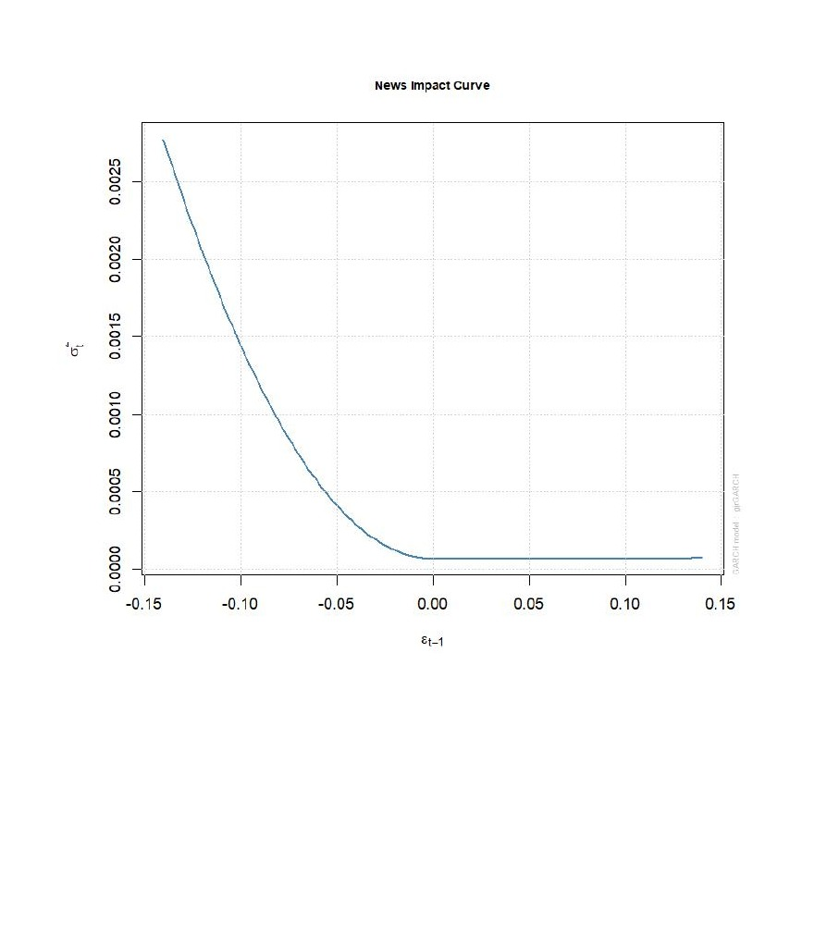
Figure 2: News Impact Curve — Asymmetric Volatility Response
Source: plot(fit3, which=12). Left tail generates far higher variance than right tail, confirming leverage effect (gamma1 = 0.138***, p < 0.001).
8.3 ACF of Squared Residuals
Figure 3 presents the autocorrelation function of squared standardised residuals from the GJR-GARCH model. Near-zero ACF values across all lags confirm that the model successfully captures the ARCH structure in returns — no significant autocorrelation remains in the squared residuals, validating model adequacy.

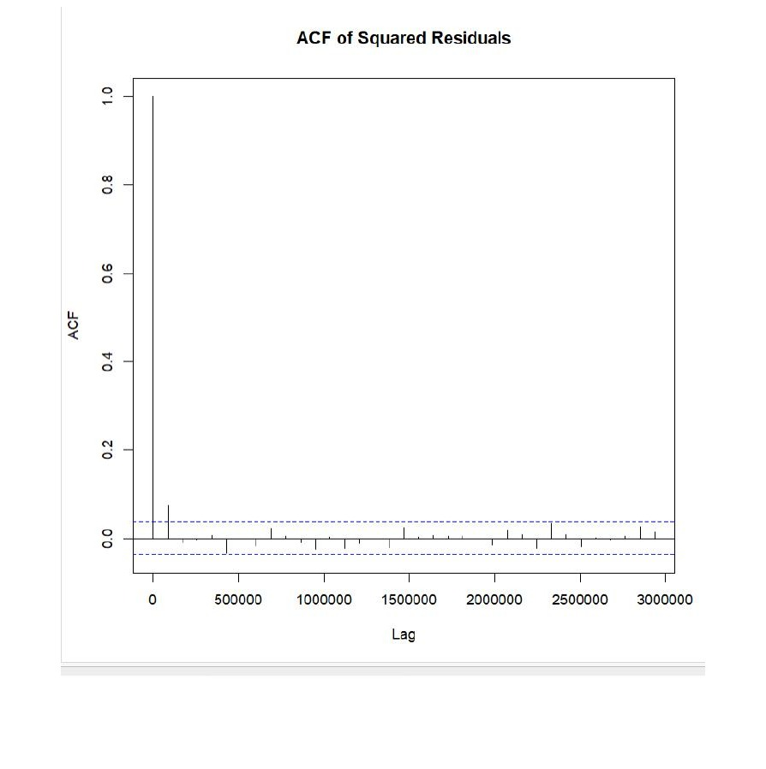
Figure 3: ACF of Squared Standardised Residuals — GJR-GARCH
Source: acf(std_res^2). All lags within confidence bands confirming no remaining ARCH effects in model residuals.
9. Sub-Period Robustness Analysis
To assess whether GPR's effect on volatility varies across market regimes, the GJR-GARCH+GPR model was re-estimated for three sub-periods: Pre-COVID (January 2015 – December 2019, approximately 1,250 observations), COVID period (January 2020 – December 2021, approximately 250 observations), and Post-COVID (January 2022 – December 2025, approximately 1,200 observations). Table 8 and Figures 4–6 summarise results.

Table 8: Sub-Period GJR-GARCH Analysis
Parameter | Pre-COVID | COVID Period | Post-COVID
AIC | -6.8224 | -5.6907 | -6.8364
BIC | -6.7936 | -5.5921 | -6.8068
Log-Likelihood | 4270.984 | 718.339 | 4115.686
beta1 (GARCH persistence) | 0.885786 | 0.882971 | 0.795903
gamma1 (Leverage) | 0.141616*** | 0.169422 | 0.189248***
vxreg1 (GPR effect) | 0.000000 | 0.000074** | 0.000000
Observations | ~1250 | ~250 | ~1200
Note: ** p<0.01, *** p<0.001. GPR effect (vxreg1) significant only during COVID period (0.000074, p = 0.0167), suggesting GPR amplifies volatility specifically during crisis regimes.
9.1 Pre-COVID Volatility (2015–2019)
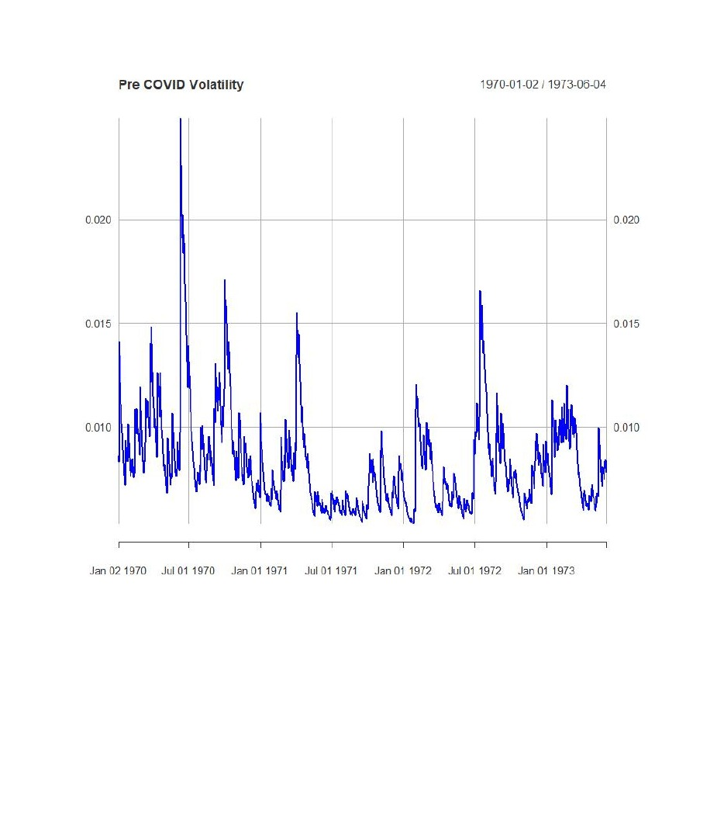
Figure 4: Conditional Volatility — Pre-COVID Period (2015–2019)
Source: plot(vol_pre). AIC = -6.8224. Moderate, clustered volatility with spike around 2016 demonetisation event. GPR effect not significant (vxreg1 p > 0.05).
9.2 COVID Period Volatility (2020–2021)
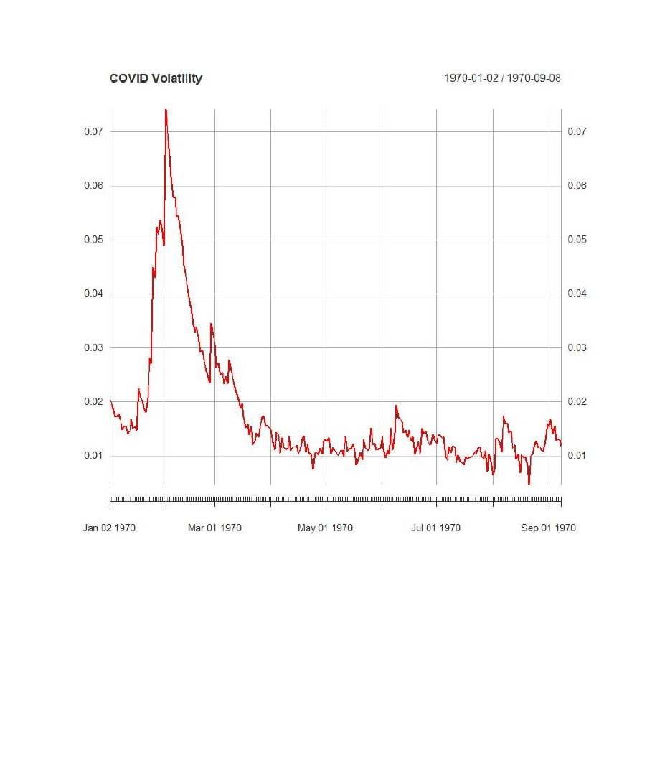
Figure 5: Conditional Volatility — COVID Period (2020–2021)
Source: plot(vol_covid). AIC = -5.6907. Massive spike in March 2020 (market circuit breakers triggered). GPR effect significant: vxreg1 = 0.000074 (p = 0.017**). GARCH persistence = 0.883.
9.3 Post-COVID Volatility (2022–2025)
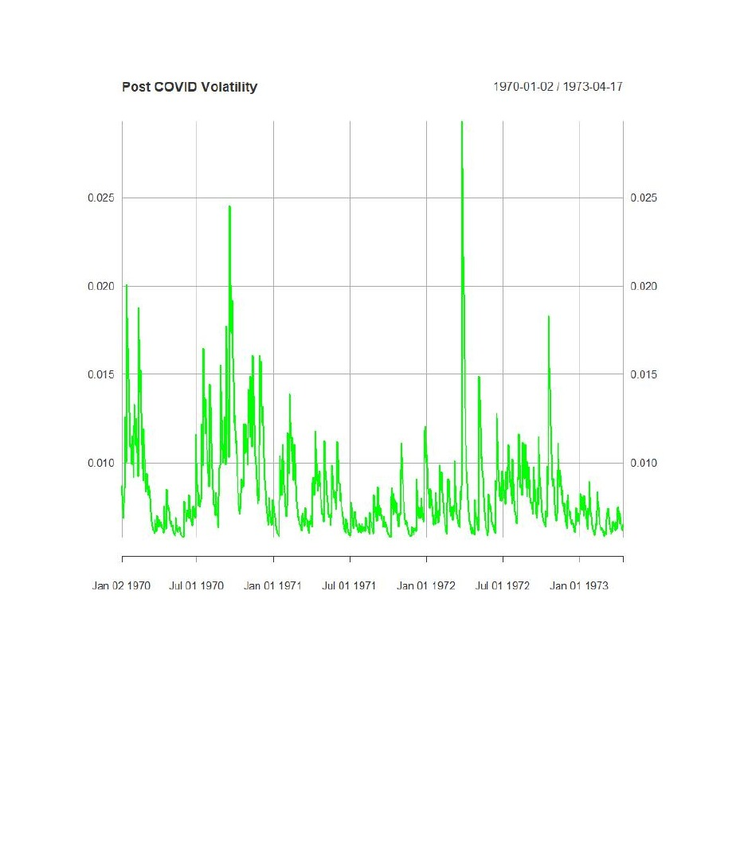
Figure 6: Conditional Volatility — Post-COVID Period (2022–2025)
Source: plot(vol_post). AIC = -6.8364. Volatility normalised post-COVID. Leverage effect (gamma1 = 0.189***) stronger than pre-COVID. GPR effect not significant (vxreg1 p = 1.0).
Sub-period findings reveal important regime-dependence. GPR's direct impact on conditional volatility (vxreg1) is only statistically significant during the COVID period (p = 0.017), where heightened investor risk-aversion likely amplified the transmission of geopolitical news to market volatility. Pre- and Post-COVID periods show insignificant GPR variance effects, though the leverage parameter (gamma1) strengthens over time — from 0.142 pre-COVID to 0.189 post-COVID — suggesting markets have become more responsive to negative shocks.
10. Conclusion
This study examined the impact of geopolitical risk on Indian stock market returns and volatility using daily NIFTY 50 data from 2015 to 2025. Five analytical frameworks were employed: descriptive analysis, ADF stationarity testing, ARIMA forecasting, VAR with Granger causality, and GARCH family volatility models.
Key findings are: (i) all return series are stationary at 1% significance level confirming suitability for time series modelling; (ii) ARIMA(5,0,4) is selected by auto.arima() though ARIMA(0,0,0) serves as a white noise benchmark, with GARCH standardised residuals confirming model adequacy (Ljung-Box p = 0.082 > 0.05); (iii) GPR does not Granger-cause NIFTY returns in the short run (p = 0.4181), though instantaneous co-movement approaches significance at 10%; (iv) GJR-GARCH with GPR achieves the best model fit (AIC = -6.7271) with a significant leverage effect (gamma1 = 0.138, p < 0.001), confirming asymmetric volatility; and (v) sub-period analysis reveals GPR amplifies volatility specifically during the COVID crisis regime.
These findings suggest that geopolitical risk operates primarily as a contemporaneous rather than a predictive driver of Indian equity returns, and that its influence on volatility is regime-dependent — strongest during periods of pre-existing market stress. Portfolio managers should monitor GPR as a real-time risk indicator rather than a leading indicator, and risk models should incorporate asymmetric volatility structures for accurate Value-at-Risk estimation in Indian markets.
References
Balcilar, M., Bonato, M., Demirer, R., and Gupta, R. (2018). Geopolitical risks and stock market dynamics of the BRICS. Economic Systems, 42(2), 295-306.
Bollerslev, T. (1986). Generalised autoregressive conditional heteroskedasticity. Journal of Econometrics, 31(3), 307-327.
Box, G. E. P. and Jenkins, G. M. (1976). Time Series Analysis: Forecasting and Control. Holden-Day, San Francisco.
Bouri, E., Gupta, R., Hosseini, S., and Lau, C. K. M. (2018). Does global fear predict fear in BRICS stock markets? Emerging Markets Review, 34, 124-142.
Caldara, D. and Iacoviello, M. (2022). Measuring geopolitical risk. American Economic Review, 112(4), 1194-1225.
Dash, S. R. and Mallick, H. (2021). Do political risks matter for equity markets? Evidence from India. Emerging Markets Finance and Trade, 57(10), 2965-2980.
Glosten, L. R., Jagannathan, R., and Runkle, D. E. (1993). On the relation between the expected value and the volatility of the nominal excess return on stocks. Journal of Finance, 48(5), 1779-1801.
Ljung, G. M. and Box, G. E. P. (1978). On a measure of lack of fit in time series models. Biometrika, 65(2), 297-303.
Pastur, L. and Veronesi, P. (2013). Political uncertainty and risk premia. Journal of Financial Economics, 110(3), 520-545.
Smales, L. A. (2021). Geopolitical risk and volatility spillovers in oil and stock markets. Quarterly Review of Economics and Finance, 80, 358-366.
Appendix: R Output

DESCRIPTIVE STATS
> basicStats(Stock_Return)
Stock_Return
nobs 2705.000000
NAs 0.000000
Minimum -0.139038
Maximum 0.084003
1. Quartile -0.004263
3. Quartile 0.005860
Mean 0.000423
Median 0.000604
Sum 1.142887
SE Mean 0.000198
LCL Mean 0.000035
UCL Mean 0.000810
Variance 0.000106
Stdev 0.010284
Skewness -1.365563
Kurtosis 20.600229

> basicStats(R_GPR)
R_GPR
nobs 2704.000000
NAs 0.000000
Minimum -Inf
Maximum Inf
1. Quartile -0.318736
3. Quartile 0.305743
Mean NaN
Median 0.000524
Sum NaN
SE Mean NaN
LCL Mean NaN
UCL Mean NaN
Variance NaN
Stdev NaN
Skewness NaN
Kurtosis NaN

> basicStats(R_USD)
R_USD
nobs 2704.000000
NAs 0.000000
Minimum -0.019648
Maximum 0.023156
1. Quartile -0.001541
3. Quartile 0.001704
Mean 0.000130
Median 0.000056
Sum 0.350727
SE Mean 0.000061
LCL Mean 0.000010
UCL Mean 0.000250
Variance 0.000010
Stdev 0.003187
Skewness 0.282786
Kurtosis 3.656763

> basicStats(R_Oil)
R_Oil
nobs 2704.000000
NAs 0.000000
Minimum -0.279761
Maximum 0.321169
1. Quartile -0.011467
3. Quartile 0.012717
Mean 0.000028
Median 0.001348
Sum 0.075588
SE Mean 0.000495
LCL Mean -0.000944
UCL Mean 0.000999
Variance 0.000664
Stdev 0.025764
Skewness -0.354099
Kurtosis 21.347826

> adf.test(Stock_Return)

Augmented Dickey-Fuller Test

data: Stock_Return
Dickey-Fuller = -14.065, Lag order = 13, p-value = 0.01
alternative hypothesis: stationary

Warning message:
In adf.test(Stock_Return) : p-value smaller than printed p-value

> adf.test(R_USD)

Augmented Dickey-Fuller Test

data: R_USD
Dickey-Fuller = -13.613, Lag order = 13, p-value = 0.01
alternative hypothesis: stationary

Warning message:
In adf.test(R_USD) : p-value smaller than printed p-value

> adf.test(R_Oil)

Augmented Dickey-Fuller Test

data: R_Oil
Dickey-Fuller = -14.053, Lag order = 13, p-value = 0.01
alternative hypothesis: stationary

Warning message:
In adf.test(R_Oil) : p-value smaller than printed p-value

> auto.arima(Stock_Return)
Series: Stock_Return
ARIMA(5,0,4) with non-zero mean

Coefficients:
ar1 ar2 ar3 ar4 ar5 ma1 ma2 ma3
-1.4943 -0.8855 0.0848 0.1270 0.0712 1.4896 0.8900 -0.0601
s.e. 0.3151 0.5533 0.5125 0.2414 0.0294 0.3158 0.5524 0.5097
ma4 mean
-0.0826 4e-04
s.e. 0.2456 2e-04

sigma^2 = 0.000103: log likelihood = 8583.54
AIC=-17145.07 AICc=-17144.97 BIC=-17080.14
ARIMA(0,0,0) MODEL
> model = arima(Stock_Return, order = c(0,0,0))
> model

Call:
arima(x = Stock_Return, order = c(0, 0, 0))

Coefficients:
intercept
4e-04
s.e. 2e-04

sigma^2 estimated as 0.0001057: log likelihood = 8543.43,
aic = -17082.87

FORECAST 15 DAYS
> forecast(model, 15)
Point Forecast Lo 80 Hi 80 Lo 95 Hi 95
2706 0.0004225091 -0.01275488 0.0135999 -0.01973057 0.02057559
2707 0.0004225091 -0.01275488 0.0135999 -0.01973057 0.02057559
2708 0.0004225091 -0.01275488 0.0135999 -0.01973057 0.02057559
2709 0.0004225091 -0.01275488 0.0135999 -0.01973057 0.02057559
2710 0.0004225091 -0.01275488 0.0135999 -0.01973057 0.02057559
2711 0.0004225091 -0.01275488 0.0135999 -0.01973057 0.02057559
2712 0.0004225091 -0.01275488 0.0135999 -0.01973057 0.02057559
2713 0.0004225091 -0.01275488 0.0135999 -0.01973057 0.02057559
2714 0.0004225091 -0.01275488 0.0135999 -0.01973057 0.02057559
2715 0.0004225091 -0.01275488 0.0135999 -0.01973057 0.02057559
2716 0.0004225091 -0.01275488 0.0135999 -0.01973057 0.02057559
2717 0.0004225091 -0.01275488 0.0135999 -0.01973057 0.02057559
2718 0.0004225091 -0.01275488 0.0135999 -0.01973057 0.02057559
2719 0.0004225091 -0.01275488 0.0135999 -0.01973057 0.02057559
2720 0.0004225091 -0.01275488 0.0135999 -0.01973057 0.02057559

LJUNG-BOX TEST
> Box.test(model$residuals, lag = 10, type = "Ljung-Box")

Box-Ljung test

data: model$residuals
X-squared = 62.223, df = 10, p-value = 1.372e-09

VAR MODEL — R_Nifty EQUATION
Estimation results for equation R_Nifty:
=======================================
R_Nifty = R_Nifty.l1 + R_GPR.l1 + R_USD.l1 + R_Oil.l1 +
R_Nifty.l2 + R_GPR.l2 + R_USD.l2 + R_Oil.l2 + const

Estimate Std. Error t value Pr(>|t|)
R_Nifty.l1 -0.0694897 0.0205562 -3.380 0.000734 ***
R_GPR.l1 -0.0003560 0.0004027 -0.884 0.376814
R_USD.l1 -0.3525991 0.0655928 -5.376 8.29e-08 ***
R_Oil.l1 0.0334840 0.0076792 4.360 1.35e-05 ***
R_Nifty.l2 0.0290541 0.0202999 1.431 0.152477
R_GPR.l2 0.0001323 0.0004029 0.328 0.742692
R_USD.l2 0.0731824 0.0655596 1.116 0.264405
R_Oil.l2 -0.0015612 0.0077512 -0.201 0.840385
const 0.0004800 0.0001970 2.437 0.014876 *
---
Signif. codes: 0 '***' 0.001 '**' 0.01 '*' 0.05 '.' 0.1 ' ' 1

Residual standard error: 0.01018 on 2691 degrees of freedom
Multiple R-Squared: 0.02103 Adjusted R-squared: 0.01812
F-statistic: 7.225 on 8 and 2691 DF, p-value: 1.606e-09

GRANGER CAUSALITY
> causality(var_model, cause = "R_GPR")
$Granger

Granger causality H0: R_GPR do not Granger-cause
R_Nifty R_USD R_Oil

data: VAR object var_model
F-Test = 1.0076, df1 = 6, df2 = 10764, p-value = 0.4181

$Instant

H0: No instantaneous causality between: R_GPR and
R_Nifty R_USD R_Oil

data: VAR object var_model
Chi-squared = 6.8742, df = 3, p-value = 0.07602

GARCH+GPR
> fit

*---------------------------------*
* GARCH Model Fit *
*---------------------------------*

Conditional Variance Dynamics
GARCH Model : sGARCH(1,1)
Mean Model : ARFIMA(0,0,0)
Distribution : std

Optimal Parameters
Estimate Std. Error t value Pr(>|t|)
mu 0.000767 0.000146 5.2637 0.000000
omega 0.000003 0.000001 2.0636 0.039051
alpha1 0.079199 0.012979 6.1022 0.000000
beta1 0.890393 0.015469 57.5598 0.000000
shape 6.499894 0.749585 8.6713 0.000000

LogLikelihood : 9073.203

Information Criteria
Akaike -6.7073
Bayes -6.6963
Shibata -6.7073
Hannan-Quinn -6.7033

GJR-GARCH+GPR
> fit2

Optimal Parameters
Estimate Std. Error t value Pr(>|t|)
mu 0.000762 0.000145 5.274659 0.000000
omega 0.000003 0.000001 2.289796 0.022033
alpha1 0.078649 0.008296 9.480121 0.000000
beta1 0.891287 0.002202 404.743398 0.000000
vxreg1 0.000000 0.000003 0.000039 0.999969
shape 6.505516 0.751274 8.659313 0.000000

LogLikelihood : 9065.117

Information Criteria
Akaike -6.7055
Bayes -6.6924
Shibata -6.7055
Hannan-Quinn -6.7008

MODEL COMPARISON
> infocriteria(fit)
Akaike -6.707251
Bayes -6.696337
Shibata -6.707258
Hannan-Quinn -6.703304

> infocriteria(fit2)
Akaike -6.705490
Bayes -6.692385
Shibata -6.705500
Hannan-Quinn -6.700751

> infocriteria(fit3)
Akaike -6.727093
Bayes -6.711804
Shibata -6.727107
Hannan-Quinn -6.721565

SUB-PERIOD AIC COMPARISON
> infocriteria(fit_pre)
Akaike -6.822374
Bayes -6.793641
Shibata -6.822437
Hannan-Quinn -6.811573

> infocriteria(fit_covid)
Akaike -5.690709
Bayes -5.592108
Shibata -5.692221
Hannan-Quinn -5.651025

> infocriteria(fit_post)
Akaike -6.836416
Bayes -6.806763
Shibata -6.836483
Hannan-Quinn -6.825247

